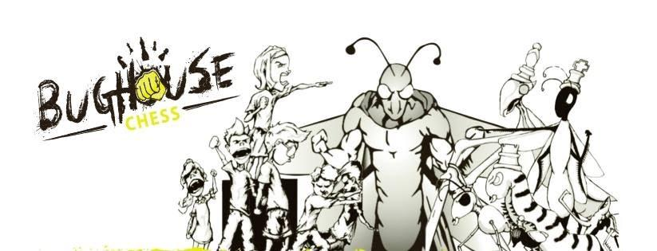

Fremont ChessFest Presents: BugHouse Chess
Scan the QR code for event Details: | 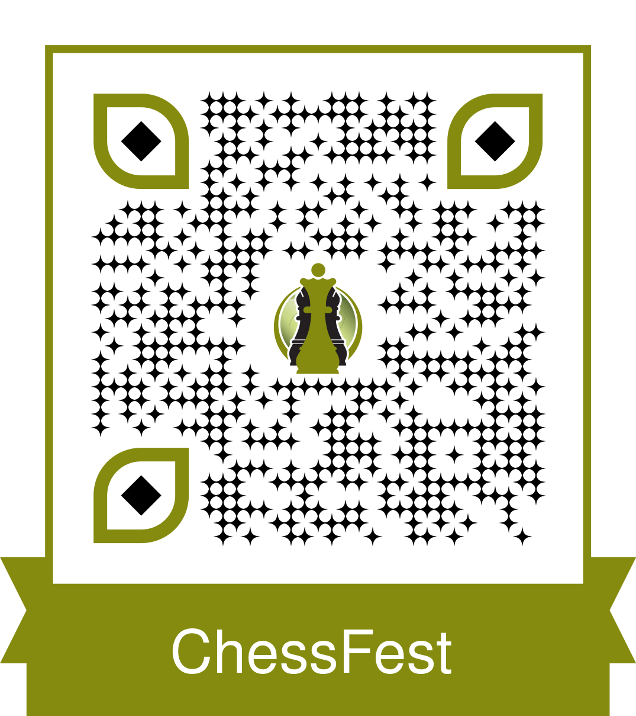

2-Player Team Chess!!!

Two players face-off against two other players. When you capture pieces you pass them to your partner and your partner passes pieces to you! You can place these pieces on your board as your move. With extra pieces on the board, things get intense! The first board with a checkmate wins for that team!

This will be an event for children ages five (5) through eighteen (18)
All participants must register for this event and there is a $6 registration fee per team. Please complete the form below and return to your chess club leader or email ImagineFremont@gmail.com

If you do not have a partner to sign up with, do not worry!
Please come to the event and we will find you a partner to play with!

Follow us on Facebook: Fremont ChessFest or go to our website: http://www.FremontChessFest.com/ 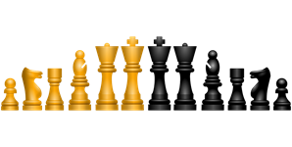
All participants must register for this event and there is a registration fee of $6 per team/$3 per person.
Please complete the form below and return to your chess club leader or mail to:
2009 Park Place Drive, Fremont, NE 68025. (Please make checks payable to Fremont ChessFest, Inc.)

Player 1 Name: _______________________________ Player 2 Name: ________________________________
Team Name: _______________________________________________________________________________
School Player 1 Attends: ______________________ School Player 2 Attends: __________________________
Contact Info: Play 1 Parent Name/Email/Phone number: ____________________________________________
Contact Info: Play 2 Parent Name/Email/Phone number: ____________________________________________
Check here: ____ if you are interested in coming to this event on scholarship (cost can be covered for those who need assistance. Anyone who wants to play can play!)

Questions? Email us at ImagineFremont@gmail.com or message us via our Facebook Page: FremontChessFest

“The beauty of chess is it can be whatever you want it to be. It transcends language, age, race, religion, politics, gender, and socioeconomic background. Whatever your circumstances, anyone can enjoy a good fight to the death over the chess board.” – Simon Williams

